**DHL Double Standards: Court victory for Tümtis in Turkey**

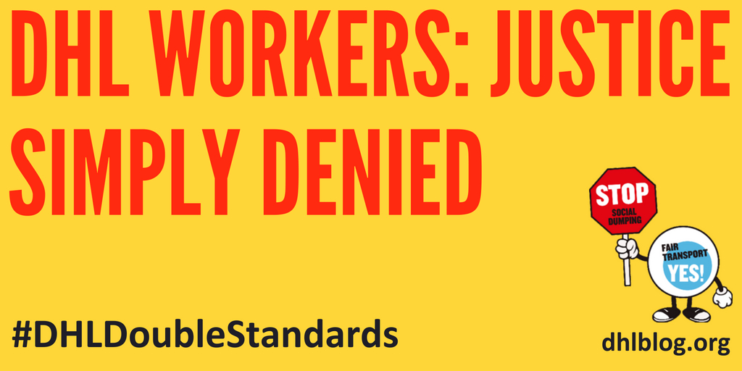

Turkish courts have today reconfirmedTÜMTIS as the representative trade union at DHL Express. ETF congratulates its Turkish affiliate on this result, and urges DHL Express Turkey to move swiftly to negotiations. TÜMTIS members have been **on the picket line since 17 July 2017**, protesting DHL Express’ denial of their legal right to a collective bargaining agreement.

The Turkish Ministry of Labour issued the official protocol to recognise TÜMTIS at DHL Express in early 2017, after registering all DHL Express trade union members. However, DHL Express management objected on 8 March 2017 and filed a lawsuit. This tactic is used to prolong the recognition process while increasing the pressure on workers through **dismissals, discrimination and intimidation**. TÜMTIS had to wait till today, Tuesday 5 June 2018, to have the Courts’ decision.

Frank Moreels, ETF President, states: “DHL needs to stop with the bullying and delays. It’s time to listen to the workers and courts, and get down to negotiating a decent agreement. In fact, this should never have happened. DHL has a global agreement with ITF and UNI, where it promises to recognise workers’ unions. So why the wait?”

DHL Express has 15 days to appeal against the Court ruling. Eduardo Chagas, ETF General Secretary, calls on all affiliates to actively participate in the [global action day](http://www.dhlblog.org/to-all-etf-itf-affiliates-of-the-road-civil-aviation-sections/) of Friday 8 June 2018. Workers around the world will send solidarity to TÜMTIS, and demand that DHL Express does not appeal against today’s Court decision.