 | Galerie Agora,  Rue du Marché aux Herbes 105, Bte 11  B-1000 Brussels  Telephone +32 2 285 46 60  Fax +32 2 280 08 17  Email: etf@etf-europe.org  www.etf-europe.org | European Transport Workers’ Federation  Fédération Européenne des Travailleurs des Transports  Europäische Transportarbeiter-Föderation  Federación Europea de los Trabajadores del Transporte

THE ETF POSITION IN FACTS AND FIGURES

THE ETF WANTS NO CHANGES IN DRIVING AND REST TIME RULES

According to the latest EC statistics (dated 2015), 14% of the cycling fatalities came as a result of crashes with large commercial vehicles (buses, coaches and trucks). Large vehicles were also responsible for 42% of pedestrian fatalities. More than 600 people, passengers and professional drivers, died in crashes involving buses, coaches and trucks.

Source EC “Traffic data basic facts 2017: Heavy goods vehicles and buses”, page 12

Belgium: in the first 5 months of 2018, between 1 and 3 accidents involving trucks, buses and coaches happened every week. In 2016 in Belgium the average number of accidents involving trucks was of 6 per day – a total of 2055 for the year.

Source Belgian press reports

The European Commission set the ambitious target to halve the number of road deaths between 2010 and 2020. Today, the Commission admits that there is a too slow of a progress towards reaching this goal. “After two years of stagnation (2014 and 2015), the number of road fatalities was reduced by 2% in 2016, and by another 2% in 2017. While the last two years give rise to some optimism, it will be very challenging for the EU to reach its ambitious target of halving the number of road deaths between 2010 and 2020” points out the EC in a factsheet published recently.

Source: EC fact sheet“2017 road safety statistics: What is behind the figures?”

THE ETF SAYS ‘NO’ TO WEEKLY REST IN THE CABIN

The maximum cabin space is of 2mx2m, no possibility for bigger cabins as the cabin size is regulated by the EU directive on weights and dimensions. This space is mainly taken by the vehicle dashboard, the stirring wheel, the driver seat and the berth. The maximum width of a berth is 80cms and many berths have a dent right in the middle, to allow the driver seat to adjust. Cabins are not provided with sanitary facilities and showers. Nor are most of the parking areas where drivers spend their nights or week-ends. The current EU rules allow the driver to spend up to 12 consecutive days in the cabin!

Source: the ETF

THE ETF CAMPAIGNS TO END DRIVER FATIGUE AND MAKE ROAD TRANSPORT SAFER FOR DRIVERS, PASSENGERS AND ROAD USERS – LONG WORKING HOURS & WORK DURING TIME OFF ARE THE NORM IN BUS AND COACH TRANSPORT

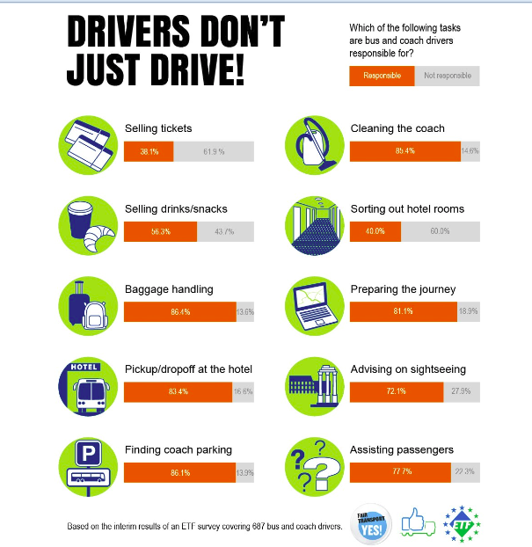

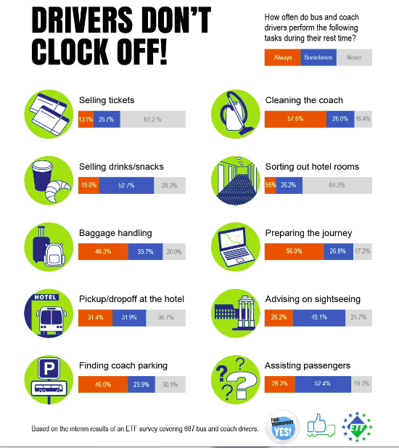

Source: 2017 ETF survey on working conditions of bus and coach drivers

THE ETF WANTS EQUAL PAY FOR EQUAL WORK FOR PROFESSIONAL DRIVERS AND WANTS THE END OF LETTER-BOX COMPANIES, A BUSINESS MODEL CREATED TO CIRCUMVENT LEGAL PAY AND SOCIAL SECURITY CONTRIBUTIONS

Letter-box companies are set up in low-income Member States for the sole purpose of accessing low-income drivers and dispatch them to work in and from Member States with much higher wages, better working condition and protection. The main interest of these companies: save money on wages and on social contributions (the lower the wage, the lower the percentage of social charges).

Wage differentials (gross salary) in road transport in 2016 for international drivers

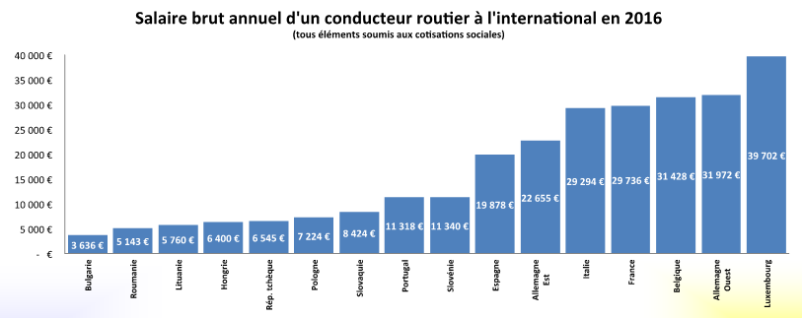

Source: Comite National Routier (CNR) “Comparative study of employment and pay conditions of international lorry drivers in Europe”, November 2016, http://www.cnr.fr/en/CNR-Publications/2016-social-synthesis-of-CNR-s-European-studies

Differentials in social security contributions between EU Member States

Source: Comite National Routier (CNR) “Comparative study of employment and pay conditions of international lorry drivers in Europe”, November 2016 http://www.cnr.fr/en/CNR-Publications/2016-social-synthesis-of-CNR-s-European-studies

THE ETF WANTS THAT CABOTAGE REMAINS A TEMPORARY ACTIVITY AIMED AT AVOIDING EMPTY RUNS, AND NOT A PERMANENT ONE AIMED TO DESTABILISE MARKETS

Current studies from the Scandinavian countries as well as EUROSTAT statistics show that cabotage has been on the increase in recent years. On behalf of the Austrian Road Haulage Association, the trade union vida, as well as the Transport and Logistics Division within the Austrian Federal Economic Chamber, the Institute for Transport and Logistics Management conducted a quantitative assessment of the extent of cabotage journeys in Austria. The findings are quite alarming: the share of cabotage operations in Austria in relation to the total domestic transport operations is about 20%; every fifth road freight transport operation in Austria is a cabotage operation. The majority of those transports are not officially declared. These illegal cabotage operations lead to damages of about 500 Million Euros per year for the state and social security services and are responsible for the loss of more than 14.000 jobs.

Source: Study by the Institute for Transport and Logistics Management conducted on behalf of Vida and WKO, March 2017

THE ETF WANTS THE ROAD TRANSPORT SECTOR TO OFFER STABLE, QUALITY JOBS. THE DRIVER SHORTAGE HAS BECOME ACUTE IN THE PAST FEW YEARS. POOR WORKING CONDITIONS MAKE THE SECTOR COMPLETELY NON-ATTRACTIVE FOR YOUNG PEOPLE OR NEW ENTRANTS. IN THIS CONTEXT, SOME MEMBER STATES MAKE A BUSINESS FROM BRINGING IN NON-EU DRIVERS, ON EVEN WORSE SALARIES AND WORKING CONDITIONS. IN 2017, 108.000 NON-EU DRIVERS RECEIVED PERMITS TO WORK IN THE EU. A PERMIT IS VALID 5 YEARS.

Number of non-EU professional drivers working in the EU for the period 2012 - 2017
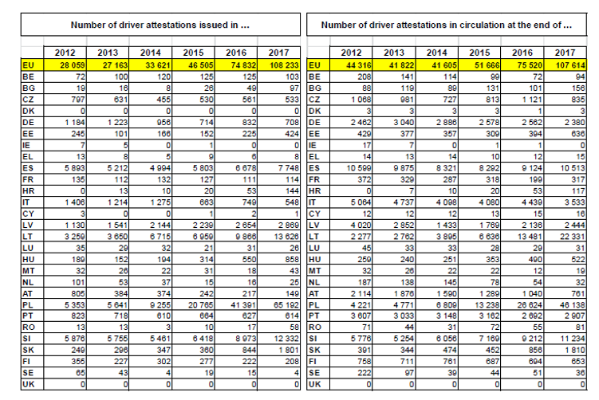
Source: European Commission statistics on drivers’ attestations issued per Member State, https://ec.europa.eu/transport/sites/transport/files/driver-attestations-in-road-freight-transport-2012-2016.pdf

