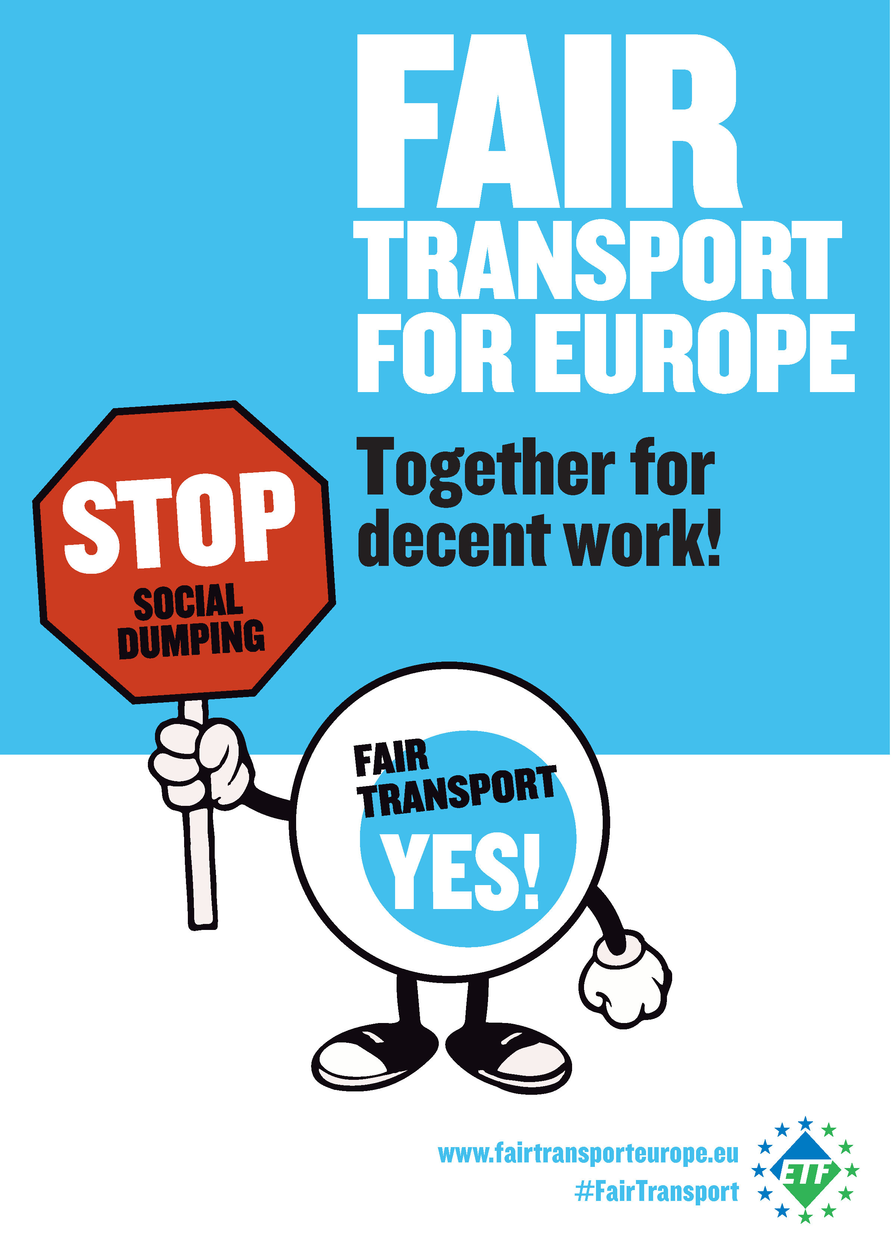

FAIR TRANSPORT FOR EUROPE
Our manifesto

Fair Transport Europe is an ETF campaign against social dumping in the European transport sector. ETF is fighting for quality jobs for transport workers and a safe, reliable and affordable service for customers. European transport trade unions are standing together to demand an end to unfair competition and exploitation.

Stop social dumping and wage exploitation

Social dumping affects transport workers all over Europe:

- Workers sent to other countries are often paid less than local employees.
- Dangerously long hours, as employers and governments ignore the rules about rest time.
- Jobs destroyed by unfair competition on the basis of cost, not quality.
- International businesses shopping for the cheapest contracts, leaving workers without clear access to healthcare and social security.
- Workers pushed onto short term and precarious contracts.
- Constant subcontracting, agency work and fake self-employment – breaking the link between staff and employers.

Companies exposed to excessive competition often react with social dumping. They avoid or abuse social regulations in the name of short-term profits. This social dumping pushes down wages and working conditions for the transport sector all over Europe. It also increases the divisions between people from different national and professional groups. That’s not just a threat to transport jobs – it’s a danger to social cohesion and people’s belief in an open European society.

Fair Transport for Europe

Another way is possible. The transport sector can create millions of quality jobs for Europeans. In particular the share of female workers in transport should increase. Secure contracts, adequate pay and fair working conditions are not outrageous demands – they are universal rights.

We cannot allow social dumping to destroy quality jobs. ETF and its affiliated organisations expect clear commitments from politicians that they will defend and develop quality work in the transport sector. That’s Fair Transport!

The proposals listed below, if implemented will certainly contribute for a fairer transport industry, where workers will enjoy decent conditions and a fair share of the wealth they contribute to generate.

- More and fair jobs for European transport workers

According to the data from the European Commission, the transport and storage services sector (including postal and courier activities) in the EU-28 employed around 11.2 million persons in 2015. Although the total employment in transport is rising, several sectors are stagnating or in decline (e. g. aviation).

As representatives of European transport workers’, we request the creation of 250,000 new, decent jobs within the next term of the EU institutions (2019 – 2024). At the same time, the jobs that would disappear due to digitalisation or automation have to be safeguarded by retraining or requalification (cf. point 7). This figure represents around 2 per cent of the current workforce in transport. Focus should not only be put on the number of jobs but also on their quality. These jobs need to be full-time, indefinite period and with decent remuneration and working conditions.

- European transport workers deserve a pay rise

In 2015, almost 10% of workers in the 28 EU Member States were living at risk of poverty, and the proportion was rising. Transport workers are vulnerable due to the mobile nature of their work as well as the exposure to social dumping and their wages are stagnating or even decreasing.
A pay rise would be good for the economy, for business, for growth, for jobs and for workers. Europe needs stronger economic demand to drive growth, as well as more investment. With more money in their pockets, workers will buy goods and services that will boost businesses and generate growth and jobs.
We therefore fully support the ETUC Pay Rise campaign and require a pay rise for all European transport workers.

- European Pillar of Social Rights must become binding

In the recent mandate, the European Commission has taken binding measures in a number of fields. Social legislation is however lagging behind and most of the initiatives are of a political nature.
As ETF, we request that the European Pillar of Social Rights becomes binding and enforceable through enforceable legislative measures and including proper sanctions for non-compliance.

- Creation of a “Social Europol”

The social legislation both at EU level and in a number of individual member states has a decent standard – it is however not properly enforced. Some countries even see the non-respect of EU social acquis as a competitive advantage. The recent proposal for the establishment of the European Labour Authority (ELA) definitely goes in the right direction but the new body does not have enough competences.

The ETF requests that the European Labour Authority is equipped with proper enforcement tools and can act both at European level as well as at national level in case of conflicts, ensuring proper implementation of the European social legislation.

- Public transport for all European cities

Public transport affects everyone. It is an integral and essential part of the modern world. Instead of privatisation and cost-optimisation, European cities should work on a sustainable transport that is accessible and affordable for everyone.
The ETF fully endorses the ITF #OurPublicTransport campaign and calls on the EU Institutions to create a framework for the development of sustainable public transport systems that provide a reliable service for an acceptable price to every citizen.

- Stop attacks on workers’ individual and collective rights

The freedom of assembly is one of the fundamental rights guaranteed by the Charter of Fundamental Rights of the EU. Economic freedoms however often enjoy primacy over these rights and recently, the European Commission launched a frontal attack on the rights of air traffic controllers by promoting minimum services and encouraging Member States to circumvent the legitimate right to strike.

The ETF requests to stop the persecution and criminalisation of trade union activities, cease the attacks on workers’ individual and collective rights and asks the EU Institutions to actively commit to their promotion.

- Stop gender-based violence on transport workers

The transport sector is still a male dominated industry and only about 20 per cent of all workers are women. A recent ETF survey shows that 63 per cent of women transport workers have experienced at least one recent act of violence at work and 25 percent believe that violence against women workers is a regular occurrence in transport. Therefore, the ETF urges the EU Institutions and the EU Member States to support the establishment of a new ILO Convention, supplemented by a Recommendation, on violence and harassment in the world of work, with a strong focus on gender-based violence, and play an important/active role in the negotiations at the International Labour Conference.

- Social dimension of automation and digitalisation

Automation and digitalisation are one of today’s biggest challenges not only for European transport workers but for the whole society. While as ETF we are not opposed to the changes this will bring, we insist that they have to be done in a socially sustainable manner and workers must not pay the price in the name of higher profits for the companies. More concretely:
- the human element must remain in the centre of all changes
- job guarantees and a fair transition must be provided for all the workers involved
- changes have to be negotiated between employers and the unions
- retraining and requalification has to be provided for workers whose jobs will disappear due to automation or digitalisation
- if necessary, dedicated taxes have to be introduced to finance dealing with the social impact of these changes

www.fairtransporteurope.eu
www.facebook.com/FairTransportEurope
#FairTransport

The European Transport Workers’ Federation is a pan-European trade union organisation representing the interests of over 5 million transport workers. We have more than 200 affiliate unions in 41 countries.
http://www.etf-europe.org/etf-news-online.cfm/newsdetail/11690/region/2/section/0/order/1

